Paul Minniti

Cosc – 120

Professor Lu

3-4-15

**The Dice Game**

**Source code**

#include <iostream>

#include <stdlib.h>

using namespace std;

int roll();

int addRoll(int b, int c);

int main ()

{

int choice, roll1, roll2, target, result;

//Introduction for the game

cout << "Welcome!" << endl;

cout << "You are playing The Dice Game." << endl;

cout << "The game begins by having the player" << endl;

cout << "toss two dice. Depending on the total," << endl;

cout << "we can have an immediate winner. Otherwise," << endl;

cout << "the game continues. If the total is a 2, 3, or 12, the house wins." << endl;

cout << "If the total is a 7 or an 11, the player wins." << endl;

cout << "If the total is 4, 5, 6, 8, 9, or 10, the game continues." << endl;

cout << "The total from the initial toss becomes the target value. The player continues tossing the" << endl;

cout << "two dice until the total matches the target or the total is 7. If the total is 7, the house wins" << endl;

cout << "otherwise, the player wins." << endl;

cout << "To roll the dice, enter 1" << endl;

cin >> choice;

//Below is the dice roller

roll1 = roll();

roll2 = roll();

result = addRoll(roll1, roll2);

cout << "You rolled a " << result << endl;

// Determines if the results of the first roll produce a win

if (result == 7 || result == 11){

cout << "Congrats, you won!" << endl;

}

if(result == 2 || result == 3 || result == 12){

cout << "Sorry, The House won! " << endl;

}

// If first roll didnt produce a win program then produces a second roll

else{

cout << "Please enter 1 to roll again " << endl;

cin >> choice;

while (choice == 1){

roll1 = roll();

roll2 = roll();

target = addRoll(roll1, roll2);

cout << "You rolled a " << target << endl;

if(result == target)// determines if the second roll equals the first roll in which case player wins

cout << "Congrats, you won" << endl;

else if(target == 7)// determines if the second roll equals seven in which case house wins

cout << "Sorry, the house won" << endl;

else// allows for replay

cout << "Please enter 1 to roll again " << endl;

cin >> choice;

}

}

}

//Below is a roll function for a random number

int roll(){

srand(time(0));

int a = 1 + (rand() % 6);

return a;

}

//Below is an addroll funtion

int addRoll(int c, int b){

int a = c + b;

return a;

}

**Pseudo code**

1. Start program
2. Introductory statements
3. Function is called to generate two random dice outcomes
4. Function call to find the sum of both die
5. Program determines if outcome is a 7 or 11 if true player wins
6. Program determines if outcome is a 2, 3 or 12 if true house wins
7. If both outcomes are false program rerolls the dice
8. If the new outcome is 7 the house wins
9. The player keeps rolling untill he rolls his first outcome then the player wins
10. The game repeats until closed

**Sample Output**

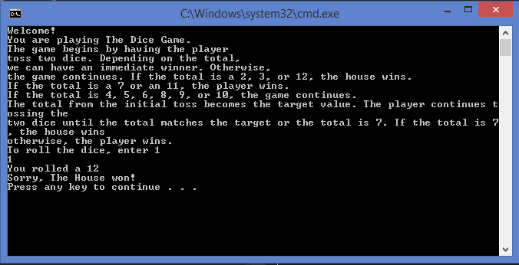

**Project report**

My program runs but its roll value never changed, I think there is a problem with the roll function. I got help from my roommate with debugging and refining. This project took me about 6 hours, although it doesn’t work right I feel it is something simple I am overlooking.